AI Workbench
Technical Architecture & Implementation Plan
Version 1.1 • May 2026 • Web + Desktop
Confidential — Internal Use Only

Table of Contents

1. Executive Summary
The AI Workbench is a modular, extensible platform for AI-powered workflows. It runs as both a web application and a desktop application from a single shared backend and frontend codebase. All AI capabilities — Agentic AI, Skills, MCP Server integrations, RAG, and Memory — are available in both deployment modes.

MongoDB stores all RAG chunks, memory, skill configurations, agent logs, and user data. The platform is designed to be plug-and-play: adding a new skill, MCP server, LLM provider, or knowledge base requires only a configuration change.

2. Goals & Design Principles

2.1 Goals
- Provide a unified AI-assisted workspace accessible from both a browser (web) and a native desktop application.
- Allow desktop users to access local file system, OS notifications, and system tray; web users get the same AI capabilities via a browser.
- Enable engineers to add new skills, agents, MCP servers, and knowledge bases without touching the core framework.
- Persist all knowledge (RAG) and session context (Memory) in MongoDB for reliability across sessions and devices.
- Support multiple LLM providers through a single abstraction layer (LiteLLM).

2.2 Design Principles
Principle | Description
Web + Desktop parity | Every feature available in the web app is available in the desktop app. The desktop adds OS-level capabilities on top.
Shared backend | A single backend service powers both the web and desktop clients. No duplicate logic.
Plug-and-play extensibility | New skills, agents, MCPs, and data connectors are self-contained modules loaded via a registry pattern.
Provider agnosticism | The LLM layer is abstracted so any provider can be swapped with a configuration change.
MongoDB as source of truth | RAG chunks, memory, skill configs, agent state, and logs all live in MongoDB.

3. Technology Stack
Layer | Technology | Rationale
Backend API | Python | Best ecosystem for AI/ML workloads; async-capable; serves both web and desktop clients.
Web frontend | TypeScript / React | Strongly typed; component-based UI; shared codebase with the desktop app.
Desktop shell | Electron | Cross-platform native window; adds local file system, OS tray, and shell access.
LLM abstraction | LLM Gateway (e.g. LiteLLM) | Single abstraction layer supporting multiple providers; swap models with a config change.
Agent orchestration | Custom Agent Runner | Full control over execution strategy; plug-and-play agent types.
RAG pipeline | RAG Framework (e.g. LlamaIndex) | Handles document ingestion, chunking, embedding, and retrieval.
Vector + document store | MongoDB | Unified store for vector embeddings, memory, skill configs, and logs; no separate vector DB required.
MCP integration | MCP SDK | Standard protocol for connecting external tool servers.
Real-time comms | WebSocket | Streaming token responses to both web and desktop clients.
Task queue | Message Queue (e.g. Redis / Celery) | Optional; supports background agent runs and scheduled tasks.
Packaging (desktop) | Desktop bundler | Single cross-platform installer (Mac, Windows, Linux).
Packaging (web) | OSS2 Container | Deployed as an OSS2 container behind a reverse proxy or cloud service.

4. Deployment Modes

4.1 Web Deployment
The frontend is served as a web application. The backend is deployed as an OSS2 container. Both communicate over secure REST and WebSocket connections. Users access the app from any browser with no installation required.

Component | Web deployment
Frontend | React SPA — served via CDN or web server
Backend | Python API server — OSS2 container, cloud or self-hosted
Database | MongoDB — cloud-managed or self-hosted
Auth | Token-based authentication (e.g. OAuth 2.0)
Comms | Secure REST API + WebSocket for streaming
File access | User uploads via browser file picker; no local file system access

4.2 Desktop Deployment
The same frontend is bundled inside a desktop shell (Electron). The backend runs as a local process started on application launch. All core features work offline with no external network dependency.

Component | Desktop deployment
Frontend | Same web frontend, embedded in the desktop shell
Backend | Python API server running locally, started by the desktop shell
Database | Local MongoDB or cloud MongoDB (user-configurable)
Auth | Local session or SSO (optional)
Comms | Local REST API + WebSocket (loopback only)
File access | Full local file system access via desktop shell IPC
OS extras | System tray icon, desktop notifications, shell command execution

4.3 Shared Codebase Strategy
- One frontend codebase shared by both web and desktop. Feature flags toggle desktop-only UI elements (local file browser, tray settings).
- A thin IPC bridge exposes desktop capabilities to the frontend. Web builds use a no-op stub so shared components work in both modes.
- The backend is identical in both deployments. Web users connect over the network; desktop users connect over loopback.

5. System Architecture

5.1 Conceptual Architecture Diagram
The diagram below shows all five layers of the platform and how data flows between them. Both the Web App and Desktop App connect to the same backend, which routes requests through the Orchestration Engine before reading from MongoDB and calling external integrations.

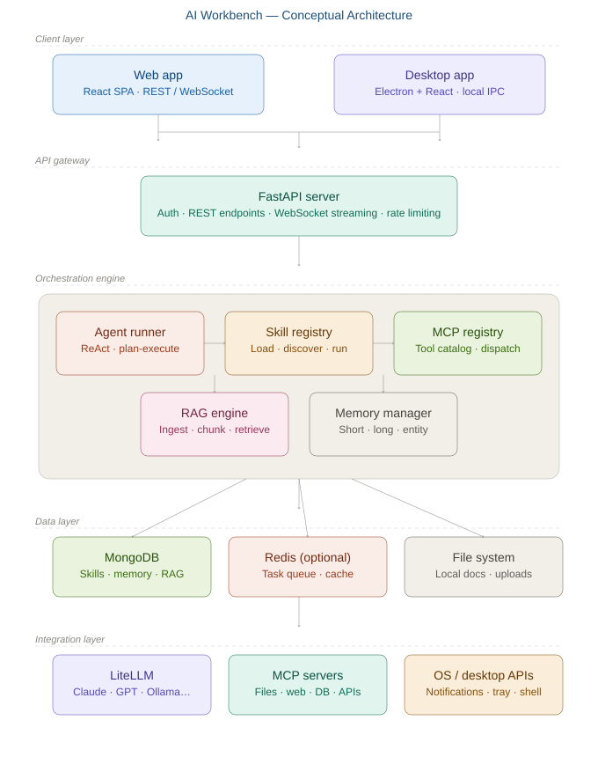

5.2 Five-Layer Model
Layer | Components
Client layer | Web: browser-based frontend. Desktop: same frontend inside a native desktop shell.
API gateway | Python backend — REST endpoints, WebSocket streaming, auth middleware, rate limiting.
Orchestration layer | Agent Runner, Skill Registry, MCP Registry, RAG Engine, Memory Manager.
Data layer | MongoDB (skills, agents, memory, RAG chunks, logs) + optional message queue (cache, background tasks).
Integration layer | LLM Gateway (multiple providers), MCP Servers (external tools), OS APIs (desktop only).

5.3 End-to-End Request Flow
The diagram below traces exactly what happens from the moment a user submits a task to when they receive a streamed response — including the RAG and Memory enrichment steps and the tool-use loop.

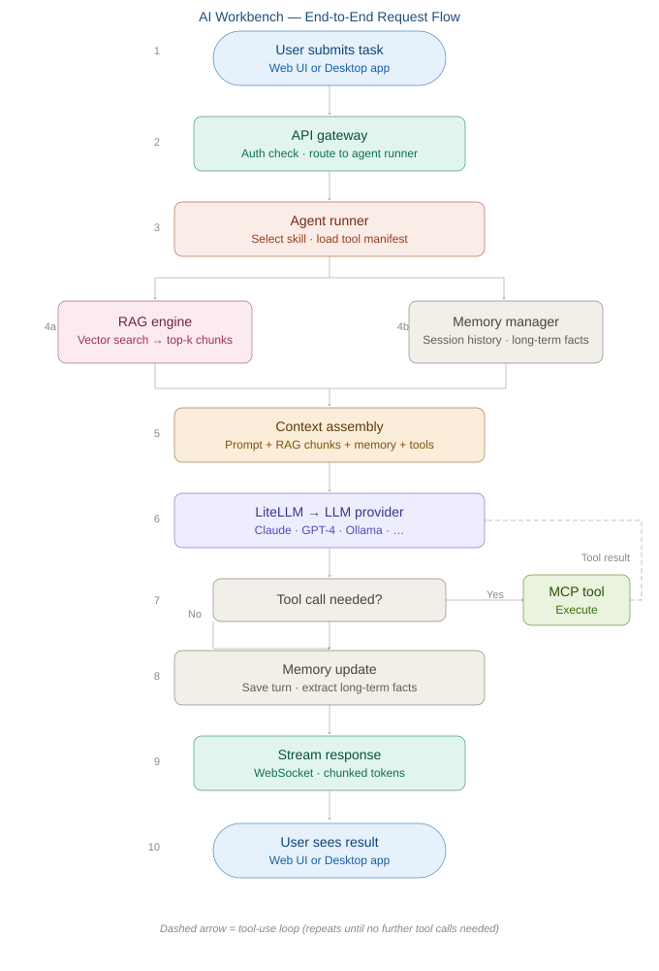

5.4 Core Components

5.4.1 Agent Runner
The execution engine. Accepts a task and skill, assembles context from RAG and memory, calls the LLM via the LLM Gateway, and loops on tool calls until a final response is ready. Supports multiple agent strategies such as ReAct and Plan-and-Execute.

5.4.2 Skill Registry
Discovers and loads skills at startup. Each skill is a self-contained module with a configuration file (name, description, prompt template, required tools, preferred model) and optional custom logic. Skills are stored in MongoDB for runtime querying and UI display.

5.4.3 MCP Registry
Maintains a catalog of connected MCP servers and their tool manifests. New servers are registered via configuration. All tools are merged into a single namespace available to the Agent Runner.

5.4.4 RAG Engine
Ingests documents by chunking, embedding, and storing them in MongoDB. At query time, retrieves the most relevant chunks by vector similarity and injects them into the agent context. Supports multiple named knowledge bases.

5.4.5 Memory Manager
Three tiers: short-term (in-session conversation history), long-term (extracted facts persisted across sessions), and entity memory (structured records for people, projects, and concepts). All stored in MongoDB.

6. High-Level Folder Structure
The repository is a monorepo with four top-level areas. Specific file names and sub-structures will be confirmed during implementation.

ai-workbench/
├── backend/ # Python API server (shared by web + desktop)
│ ├── core/ # Agent runner, skill registry, MCP registry
│ ├── skills/ # Plug-and-play skill modules
│ ├── rag/ # RAG ingestion and retrieval
│ ├── memory/ # Short-term, long-term, entity memory
│ ├── api/ # API route handlers
│ └── db/ # Database connection and helpers
├── frontend/ # TypeScript / React SPA (web + desktop)
│ ├── src/
│ │ ├── components/
│ │ ├── pages/
│ │ └── desktop-bridge/ # IPC bridge (no-op stub for web)
│ └── package.json
├── desktop/ # Desktop shell (Electron)
│ ├── main/ # Main process: window, backend lifecycle
│ └── ipc/ # IPC handlers: file system, tray, notifications
├── config/ # Skill manifests, MCP server list, app settings
├── deploy/ # OSS2 container and infrastructure configs
├── docs/ # Architecture docs, ADRs, runbooks
└── tests/

7. MongoDB Data Models
Collection | Purpose | Key Fields
skills | Registered skill configs | name, description, prompt_template, tools, model, enabled
mcp_servers | Connected MCP server registry | name, endpoint, tools[], auth_type, enabled
rag_chunks | Document chunks + embeddings | doc_id, chunk_text, embedding[], metadata, namespace
memory_short | In-session conversation history | session_id, messages[], created_at, user_id
memory_long | Persistent extracted facts | user_id, key, value, embedding[], updated_at
memory_entities | Structured entity records | name, type, attributes{}, last_seen
agent_runs | Execution logs | run_id, skill, steps[], input, output, duration, status
users | User profiles and preferences | user_id, name, preferences{}, default_model, deployment_mode

8. Plug-and-Play Extension Guide

8.1 Adding a New Skill
- Create a new skill module folder under the skills directory.
- Add a configuration file with: name, description, prompt template, required tools, and preferred model.
- Optionally add custom handler logic for pre/post-processing.
- Restart the backend — the Skill Registry auto-discovers and registers it in MongoDB.

8.2 Adding a New MCP Server
- Register the new server in the MCP server configuration file with its name, endpoint, and auth method.
- The MCP Registry fetches the server’s tool manifest at startup and merges all tools into the shared namespace.

8.3 Adding a New LLM Provider
- All LLM calls go through the LLM Gateway abstraction layer. Add the new provider to the application settings.
- No code changes required — any provider supported by the gateway is immediately available to all agents and skills.

9. UI Rich Text Rendering
The AI Workbench UI uses three complementary libraries to render rich text across different surfaces. Each is chosen for a specific job so no single library is stretched beyond its purpose.

Surface | Library | Why
Chat / agent responses | react-markdown | Converts Markdown strings to React elements. Lightweight and read-only — ideal for streaming LLM output token by token.
Code blocks | Shiki | Uses VS Code grammar files for syntax highlighting. Works as a plugin inside react-markdown or standalone anywhere in the UI.
Editable content (skill prompts, memory notes, documents) | Tiptap (ProseMirror) | Full WYSIWYG editor with slash commands, toolbar, and tables. Stores content as JSON and can import/export Markdown for LLM compatibility.
Simple labels and tooltips | Native HTML | No library overhead needed for short inline text.

9.1 Chat Pane (react-markdown)
All agent and LLM responses are streamed as Markdown and rendered using react-markdown. The following plugins are included:
- remark-gfm — enables GitHub Flavored Markdown: tables, strikethrough, task lists, and autolinks.
- rehype-highlight or rehype-pretty-code — syntax highlighting for fenced code blocks.
- rehype-sanitize — strips unsafe HTML from LLM output before rendering.

This stack mirrors what Claude desktop and claude.ai use for rendering assistant messages, giving users a familiar and consistent experience.

9.2 Editable Content (Tiptap)
Any surface where the user actively writes or edits content uses Tiptap, which is built on ProseMirror. This includes skill prompt templates, memory notes, and any document drafting features. Key capabilities:
- WYSIWYG editing with headings, bold, italic, lists, tables, and code blocks.
- Slash command menu for inserting blocks quickly.
- Content stored as structured JSON (ProseMirror document model).
- Markdown import/export so content can be passed to and from the LLM layer without conversion loss.

9.3 Code Syntax Highlighting (Shiki)
Shiki is used for all code block rendering throughout the UI. It uses the same grammar files as VS Code, so syntax highlighting is accurate and familiar. It runs at render time with no runtime grammar loading, making it suitable for both server-side and client-side use.

10. Implementation Roadmap
Phase | Focus | Key Deliverables | Est.
Phase 1: Foundation | Core infrastructure | Backend API, MongoDB integration, LLM Gateway, Skill Registry, 2 starter skills | 2–3 wks
Phase 2: Agents + MCP | Agent execution | Agent Runner, MCP Registry, initial MCP server integrations, streaming responses | 2–3 wks
Phase 3: RAG + Memory | Knowledge & context | RAG ingestion and retrieval pipeline, short- and long-term memory | 2–3 wks
Phase 4a: Web UI | Browser deployment | React frontend, chat UI, Skill launcher, Settings panel, OSS2 container deployment | 2–3 wks
Phase 4b: Desktop UI | Desktop shell | Desktop wrapper, IPC bridge, local file browser, system tray, packaged installer | 2–3 wks
Phase 5: Polish & Ship | Production readiness | Auth, logging, telemetry, auto-update, end-to-end tests, CI/CD pipeline | 2–3 wks

11. Security Considerations
- All credentials and API keys are stored in environment variables or a secrets manager — never hard-coded.
- Web deployment: backend sits behind a reverse proxy with HTTPS; all endpoints require authentication.
- Desktop deployment: the backend binds to loopback only; the desktop shell communicates locally and requires no inbound network access.
- Local file system access is limited to user-approved directories.
- All agent actions and tool calls are logged to MongoDB for auditability.

12. Recommended Next Steps
- Approve this architecture and dual-deployment strategy.
- Scaffold the monorepo with the top-level folder structure agreed in Section 6.
- Provision a MongoDB instance and configure environment variables.
- Build Phase 1: backend API, LLM Gateway integration, Skill Registry, and 2 starter skills.
- Build Phase 4a (web) and Phase 4b (desktop) in parallel once the backend is stable.

This document will evolve as the platform is built. Major decisions should be recorded as Architecture Decision Records (ADRs) in /docs/adr/.

